Contents

Class11.Permissions Detail 1

1.Peoples and groups 3

2.Site permissions 3

3. Check Permission 5

Access Request Settings 8

Site Collection Administration 9

# Class11.Permissions Detail



**Permissions:** We talking about sites

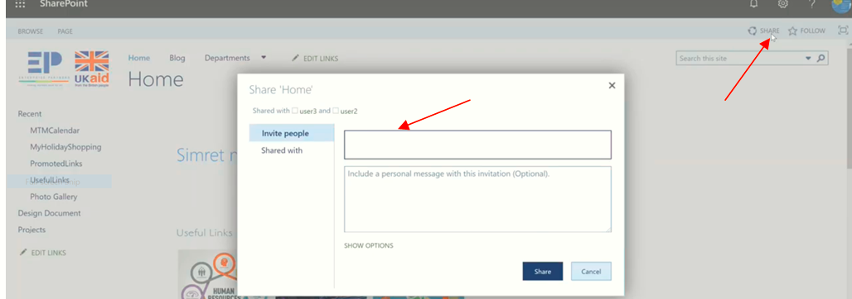

The word **Share** is related to Permissions. When we click on it we get the invitation pop up. but it needs permission nobody can’t share. For the time we don’t do that way.

To know the place where our invited person is landed, look the following picture.

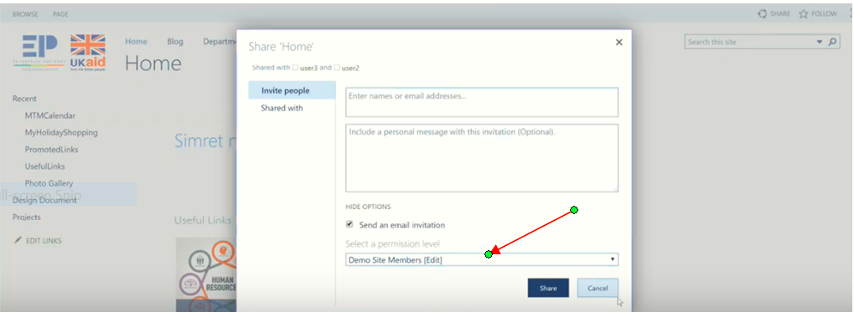

**User and Permissions**

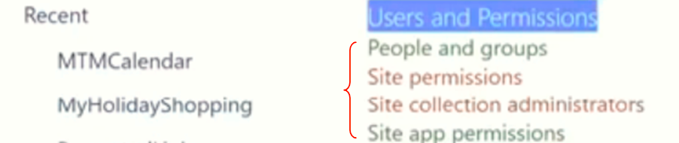

**Remember the Group.**

**Group p is the collection of users.**

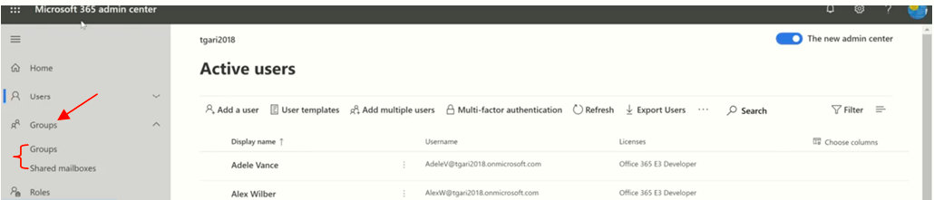

This group uses for all below directories. But we didn’t use for this time our level.AD(Active Directory group job ), you knew Share point and AD group.

## 1.Peoples and groups

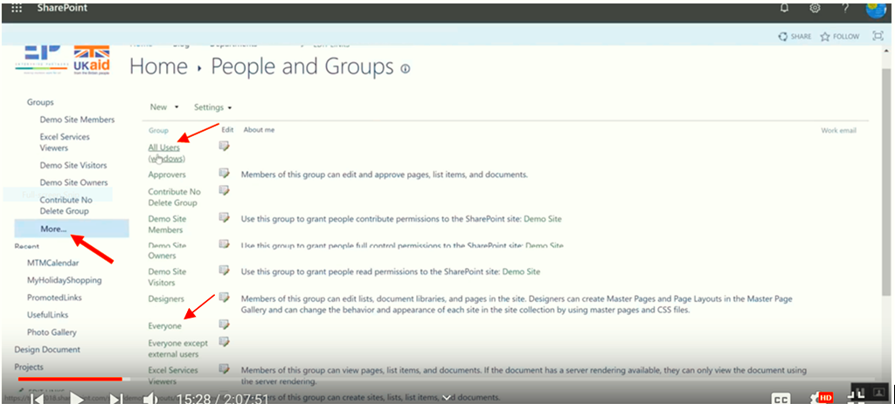

If we click more we get all permissions groups. In this case all users have permission to **read windows**.

If the new employee hired we don’t worry, easily we group in everyone gradually we give him/her special permission.

## 2.Site permissions

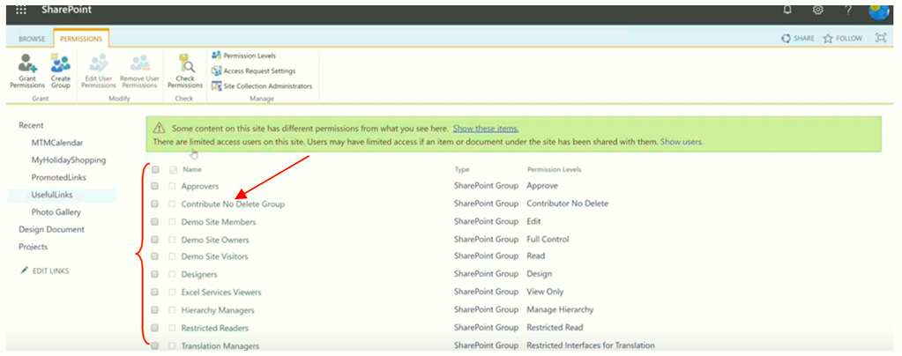

This is the parts of the previous groups which have permissions. For example we didn’t see **everyone** here. Remember last time we create **Contribution No Delete Group**.

**To Add Users or Groups in this permission**

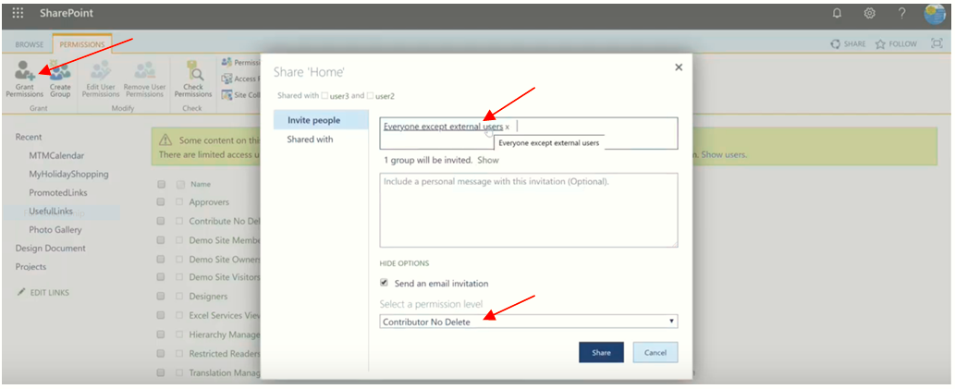

**Look the following:** as you knowGrant means Give so Grant permission means give permission.

**Grant**

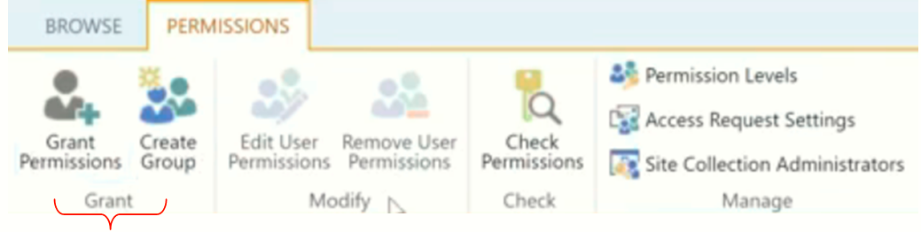

1. **Grant Permission:** Give Permissions to users and groups.
2. **Create Group:** Create a new SP group. This group will be available through this site collection.

**Create HR Group**

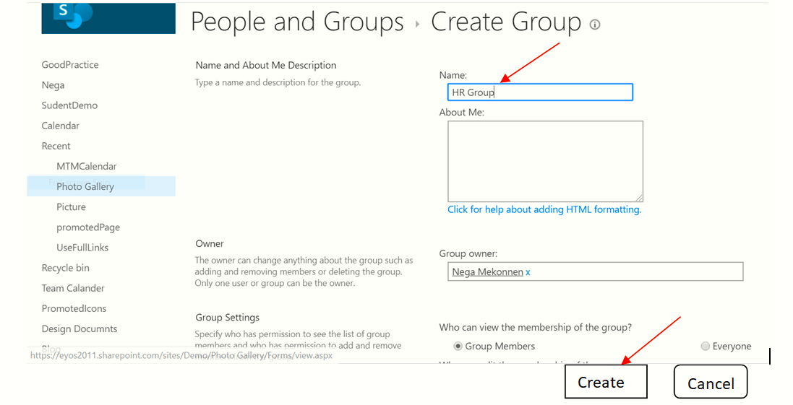

**We get**

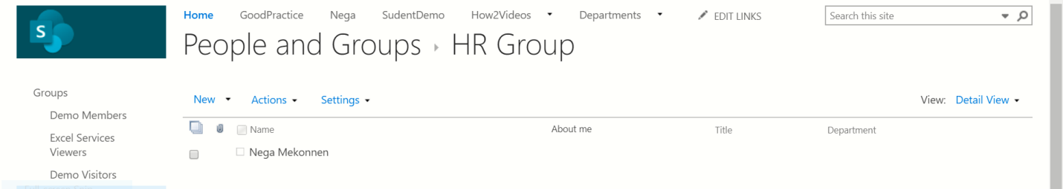

We will see that group in SP group: Site setting => Permission

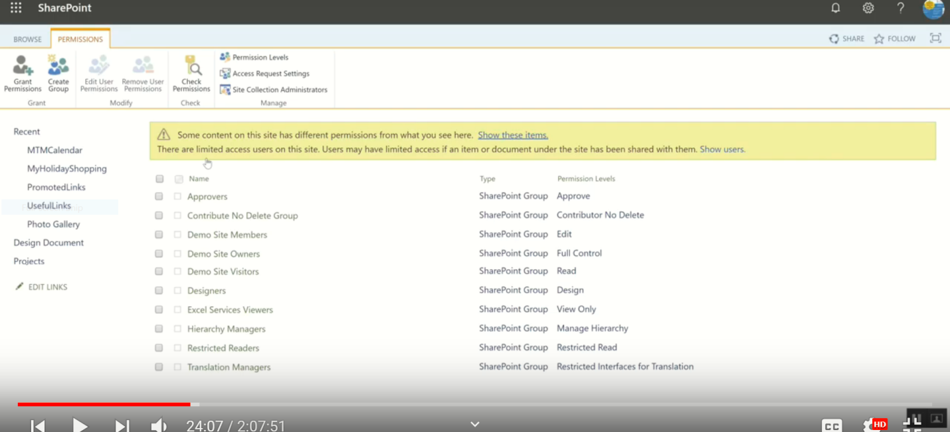

We didn’t see that group in this group, because we didn’t gave permission for that group. It is in people and groups.

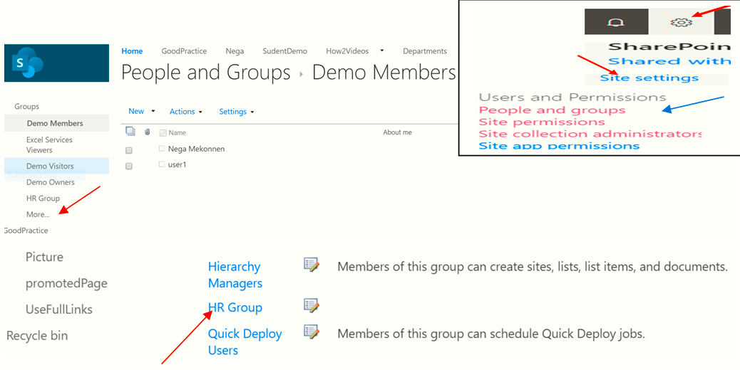

3. Check Permission**:**

To check users in group use  **check group**

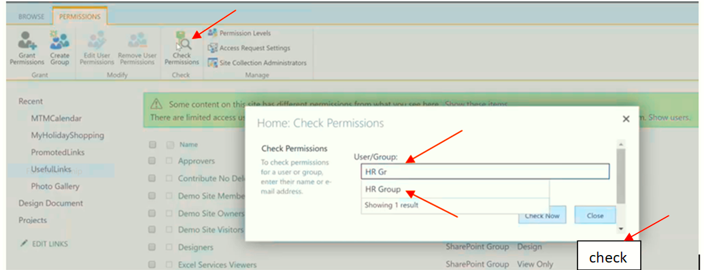

**Manage** 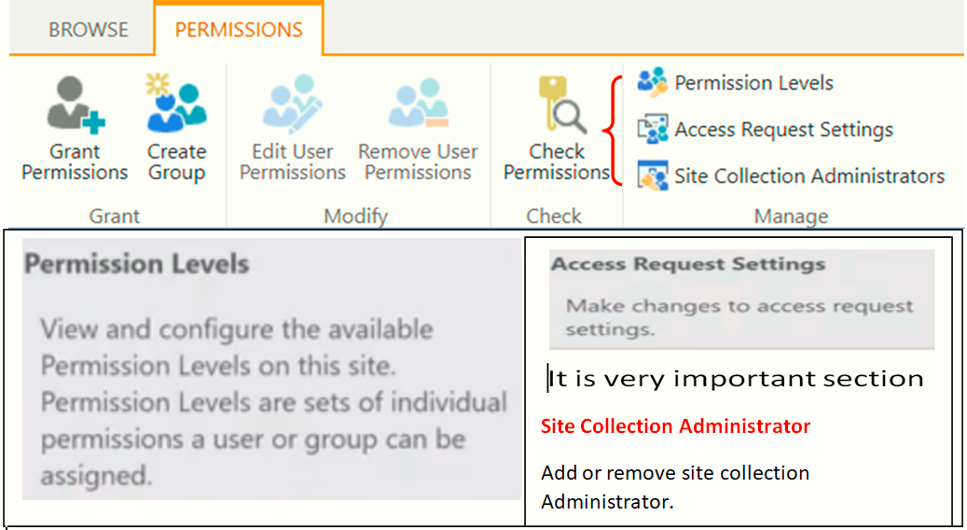

**Example:** Create User2 and check it. Check it first

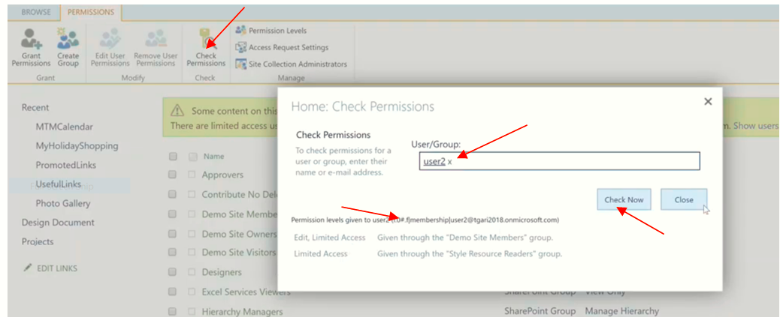

So we need to create for user2. (**First copy Root site URL => ellipse => new incoming windos**)

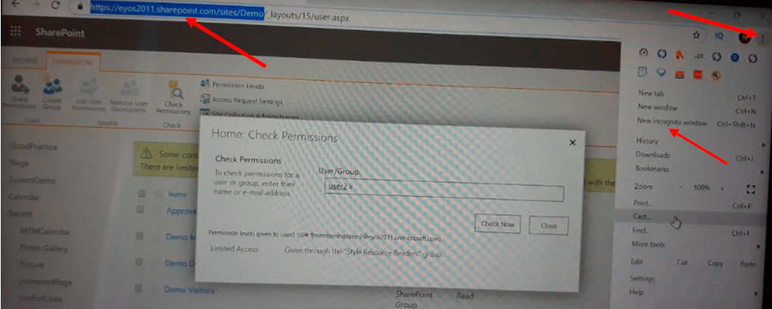

Then (**paste URL at the title bar => username => password => write the message & then request**)

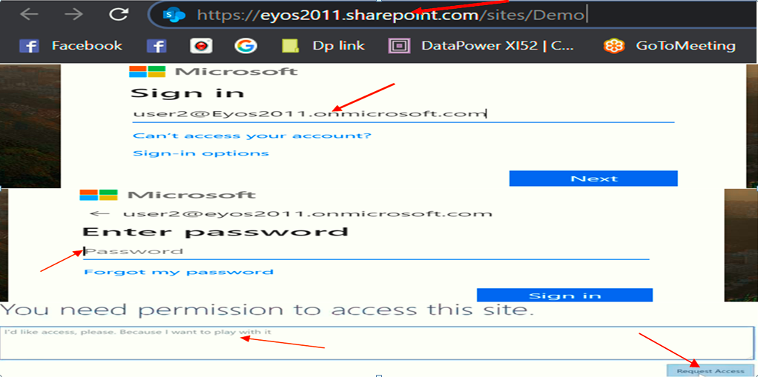

Then we get

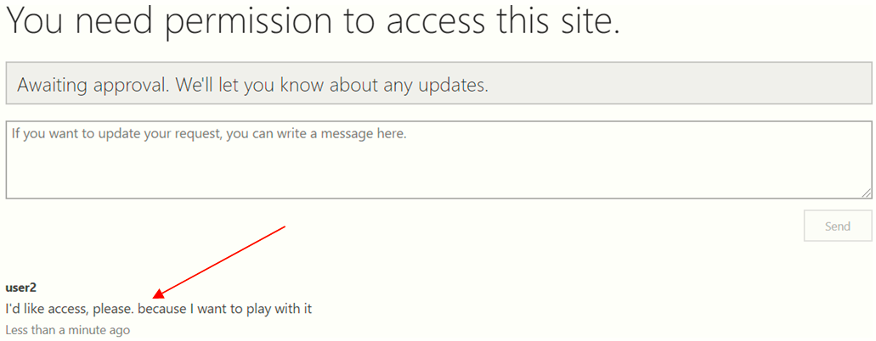

**As we have seen, He send request but nobody access his request**

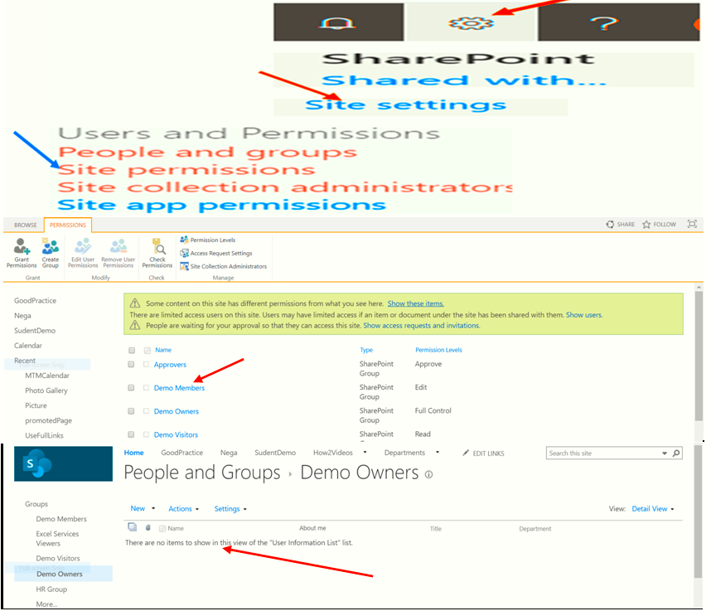

**So to access his request we follow the following steps**

## Access Request Settings

**Who access his request (Demo Owners or Admin?)**

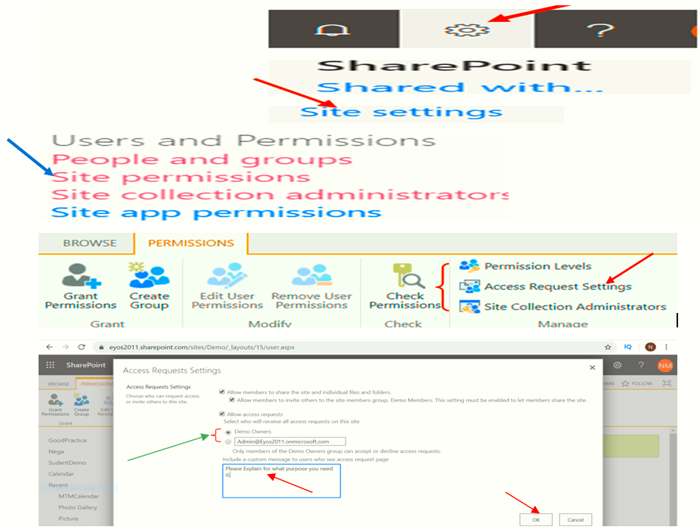

## Site Collection Administration

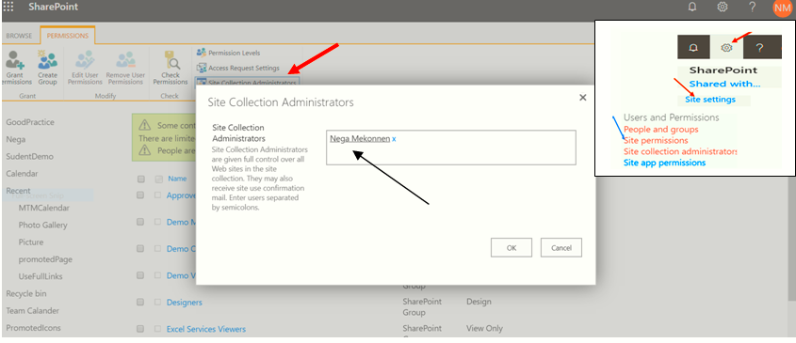

We can add other users in here

**NB: Look the following**

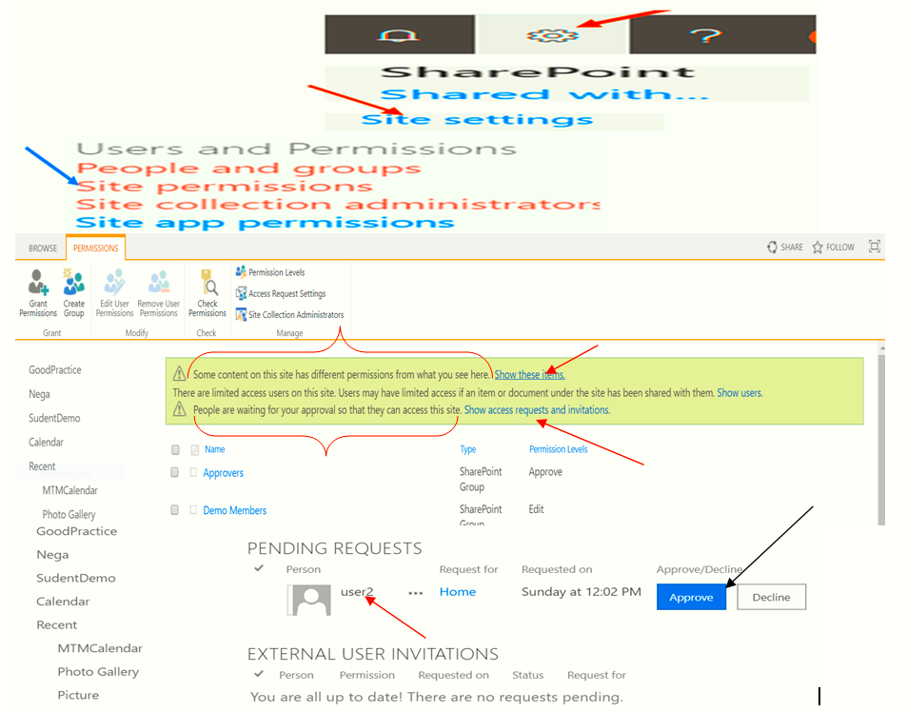

Why we approve him?

**User2** I'd like access, please. Because I want to play with it.

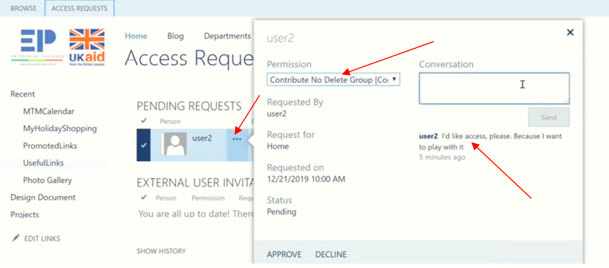

Then we add him to Contribute to delete group.

By declining the above process and (site setting => site permission) we get the following

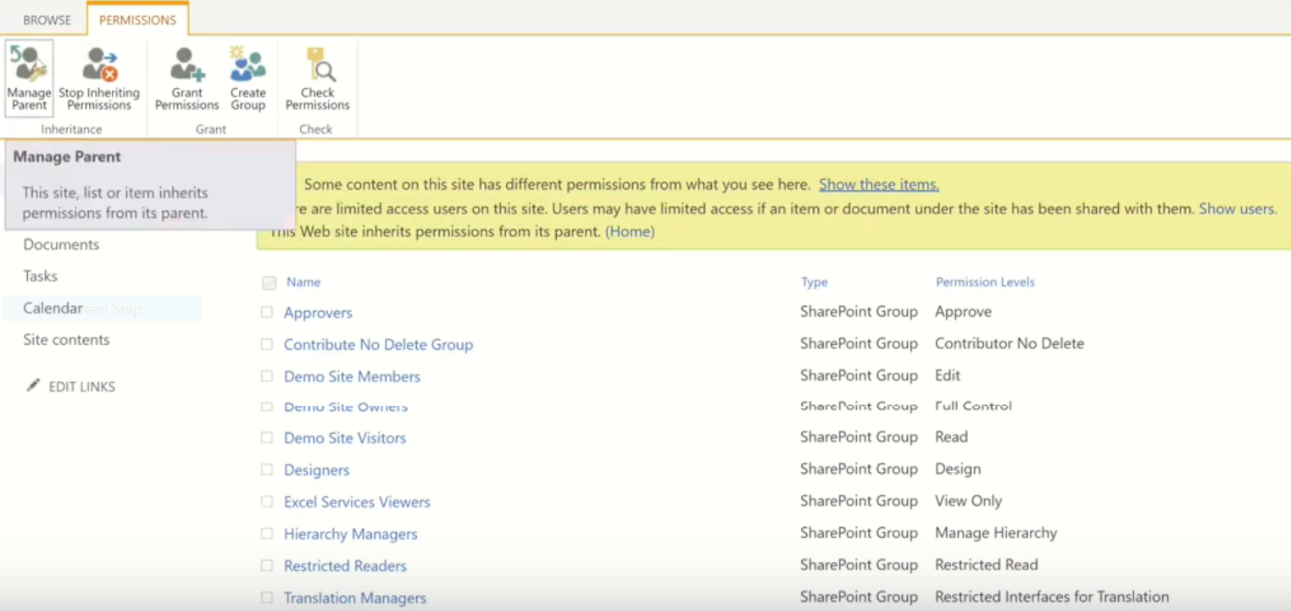

In this step we can’t select the check box and we can’t delete them

**Simply to see don’t do this.**

To delete select the check box and to delete them we need to go root site by using manage parent.

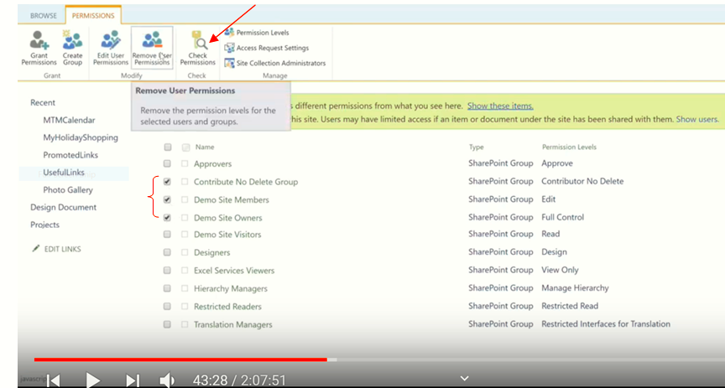

By using the back arrow we can come back.

**NB**: The more access you have the more responsibility you have.

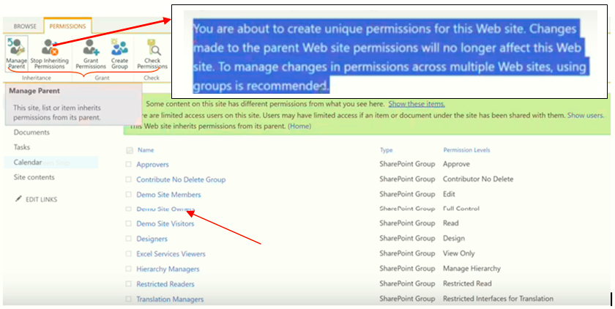

**Keep the Demo Site Owners.**

**By clicking “I’m ok with that” we get**

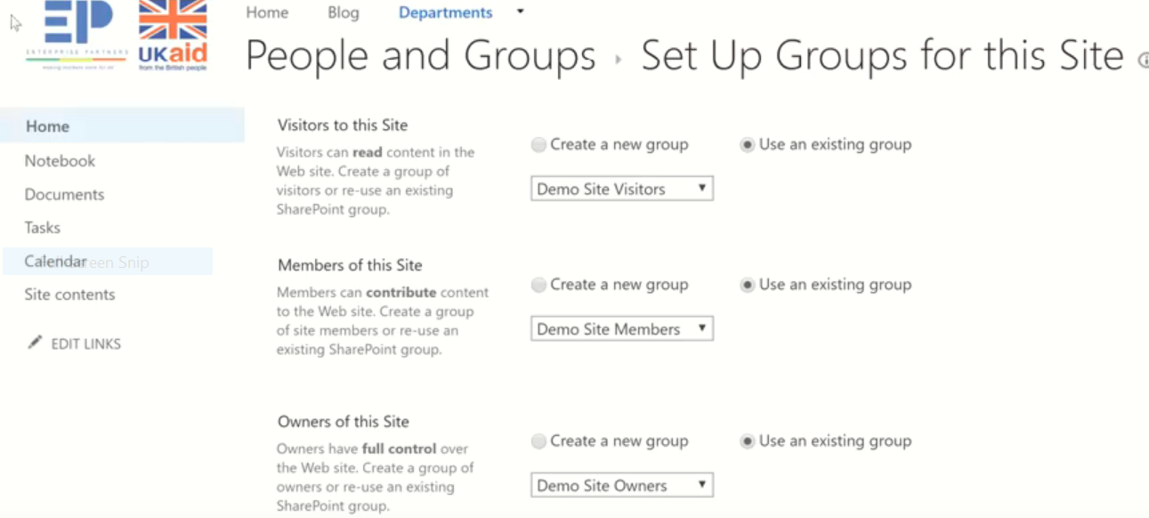

Site setting =>site permission

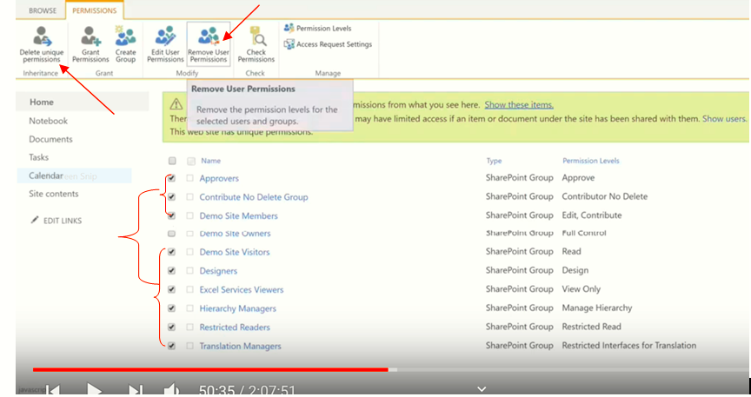

Then we get

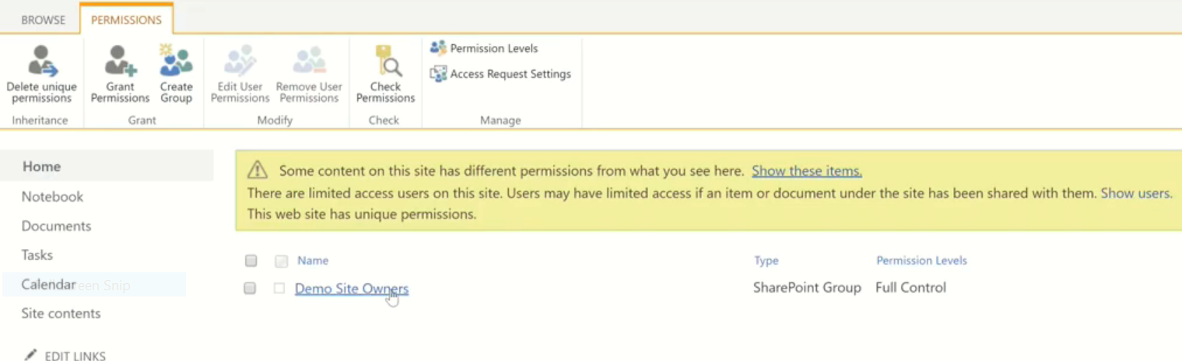

This shows anybody doesn’t have access on HR department.

**NB**: we take everybody permission of before we do anything in this site.

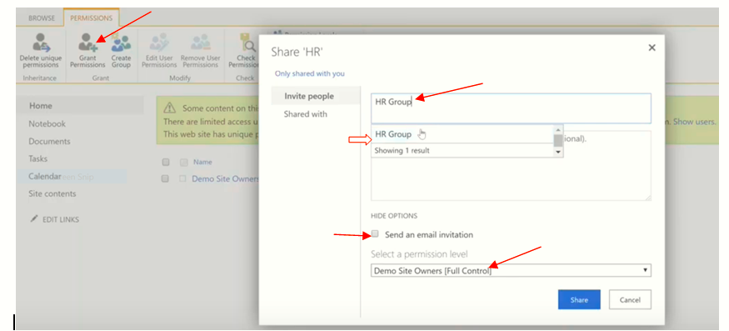

We get

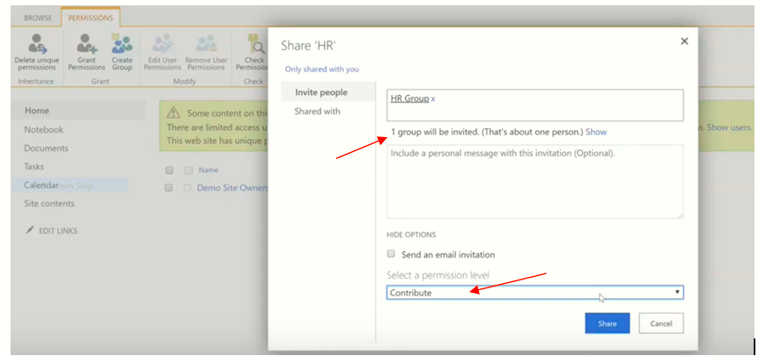

**And then**

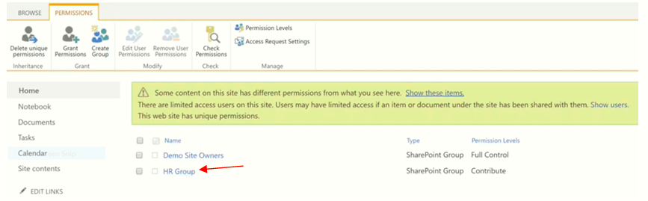

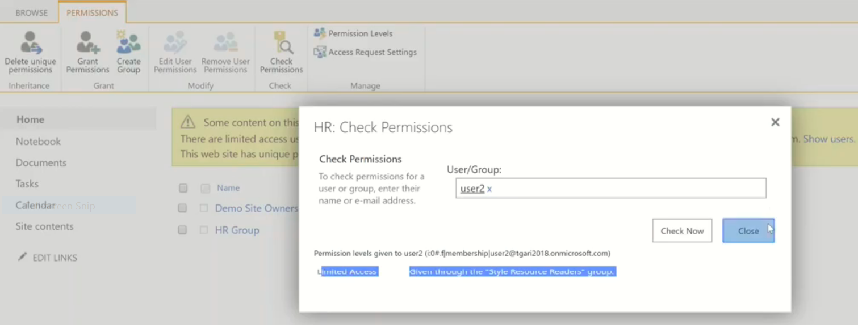

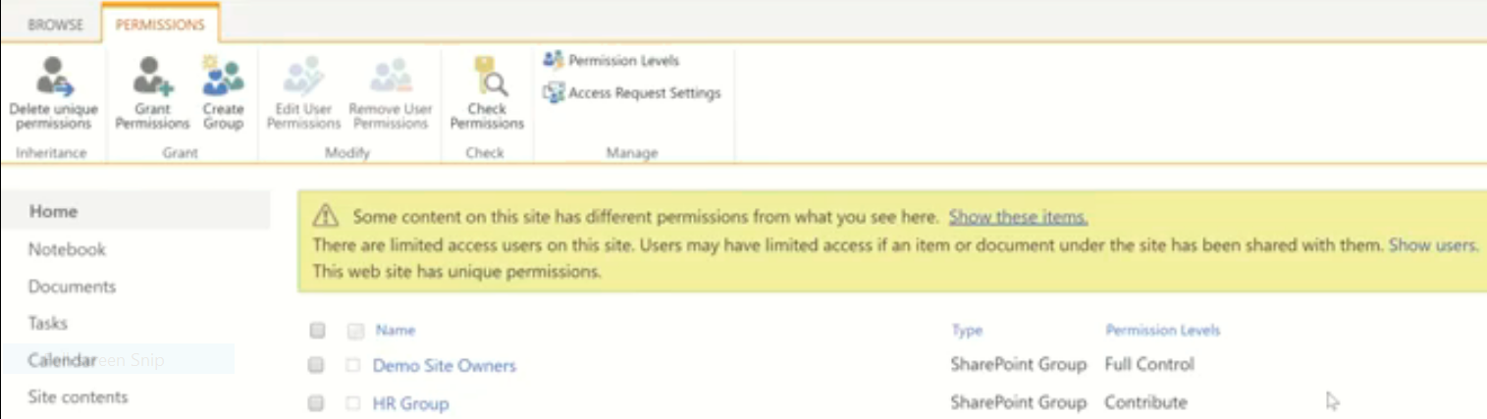

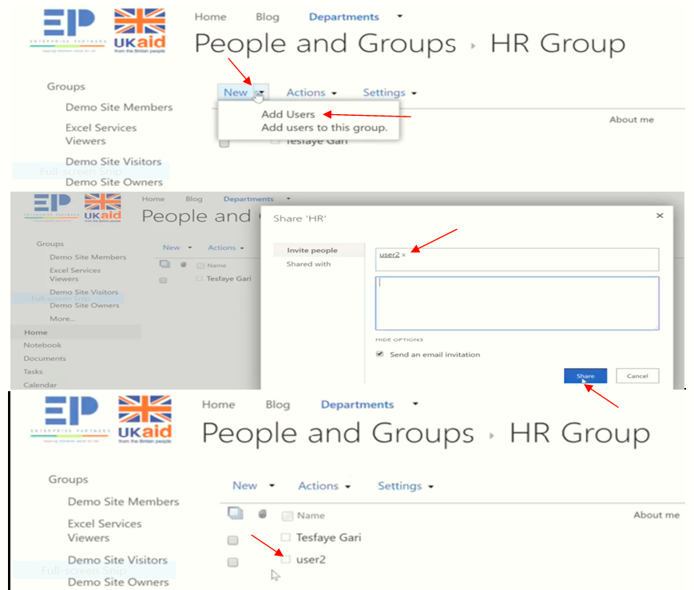

**Check User2:**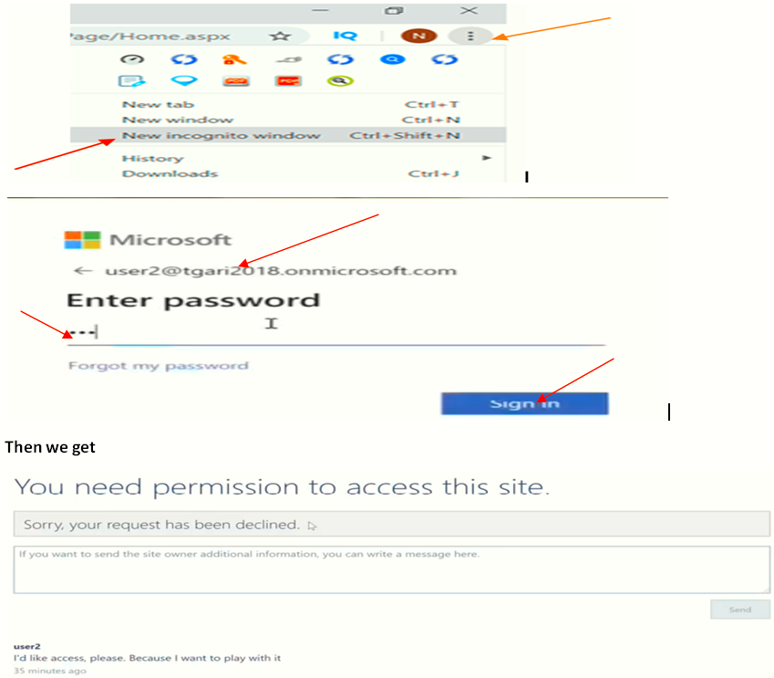

1:12

**Blog Site**

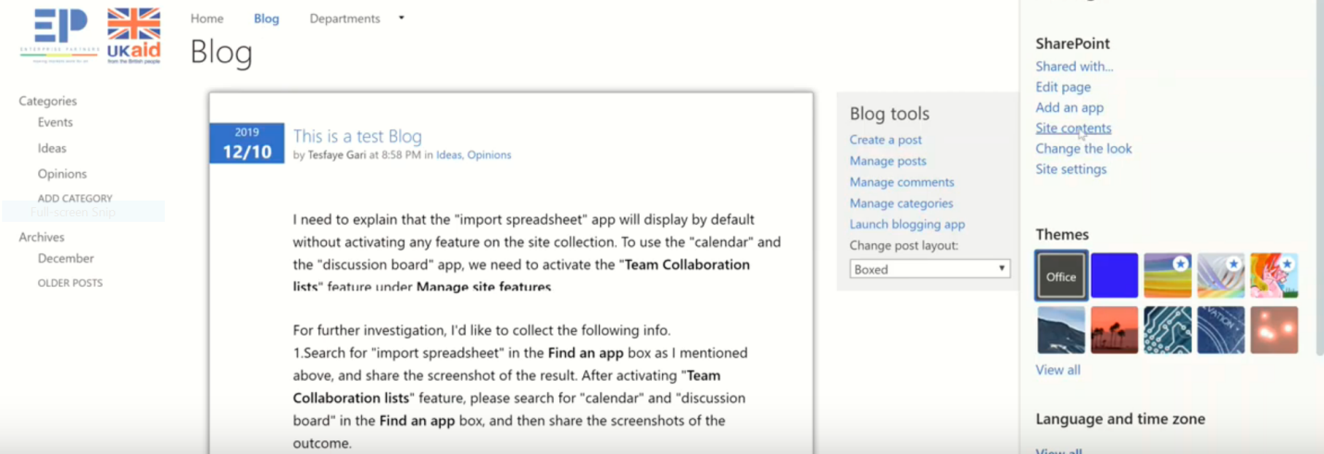

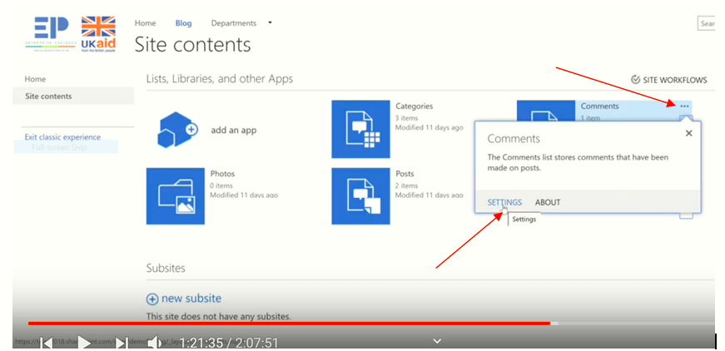

* Every single Comment goes to Comments
* Every single Posts goes to Posts

**HR Departments**

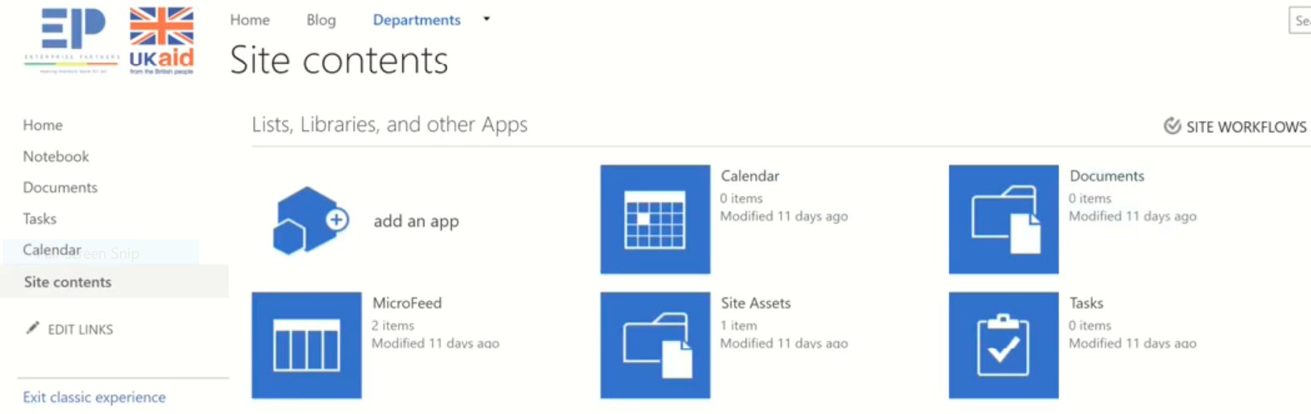

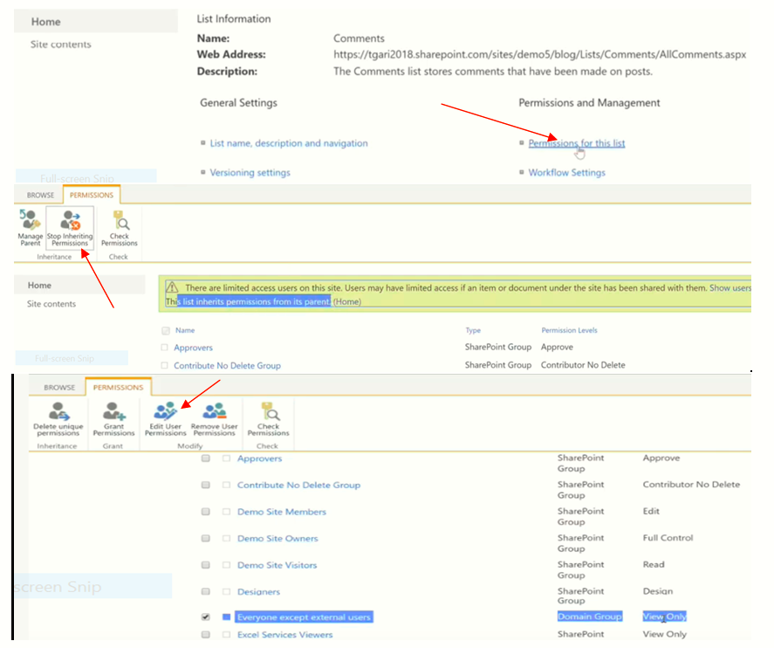 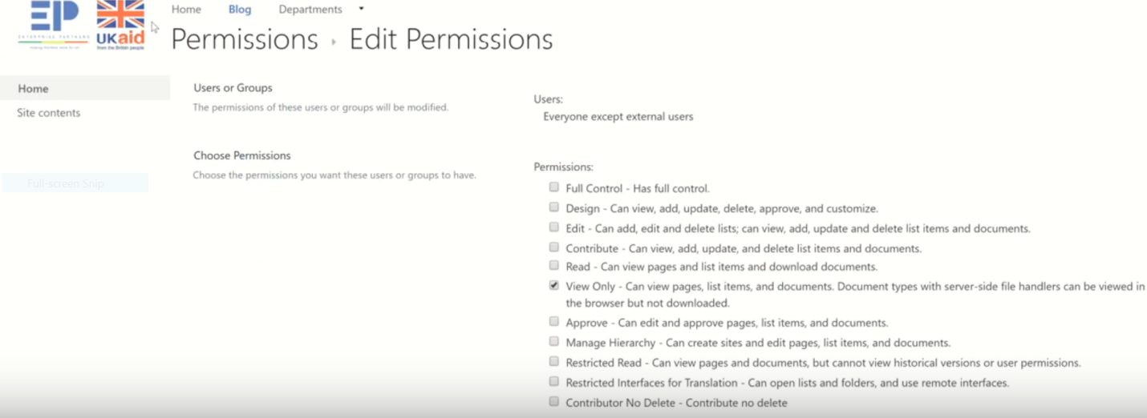

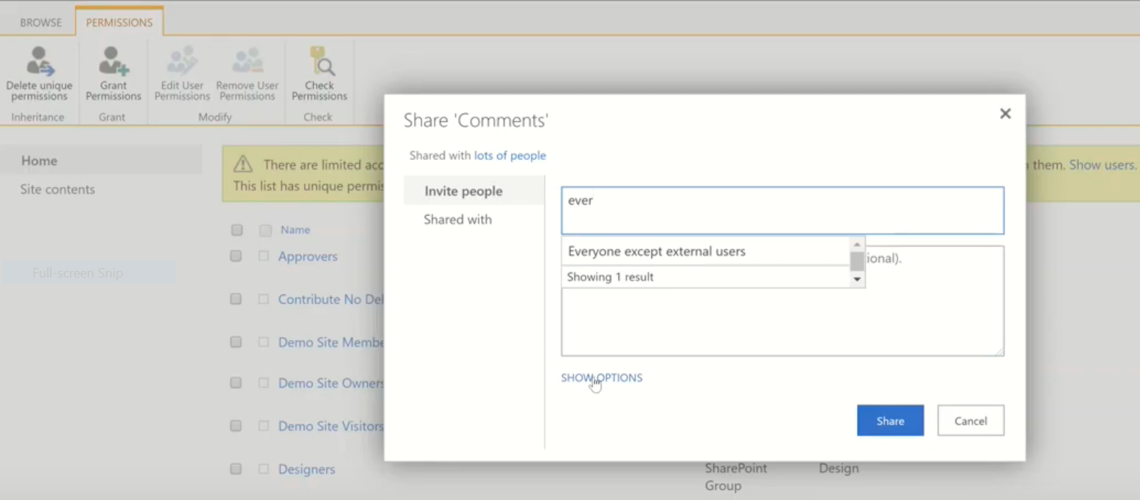

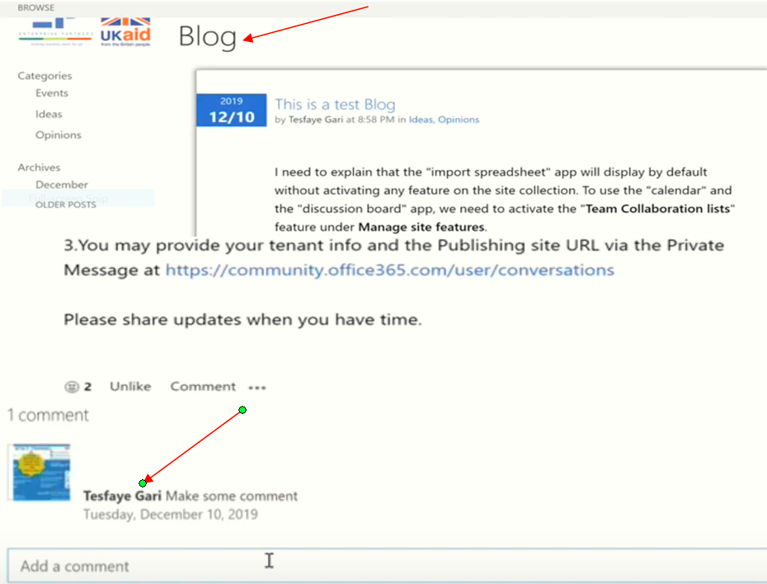

We get the comment by refreshing it

**To give restricted access**

**Least privilege** is the concept and practice of restricting **access** rights for users, accounts, and computing processes to only those resources absolutely required to perform routine, legitimate activities. **Privilege** itself refers to the authorization to bypass certain security restraints.

**EX.**

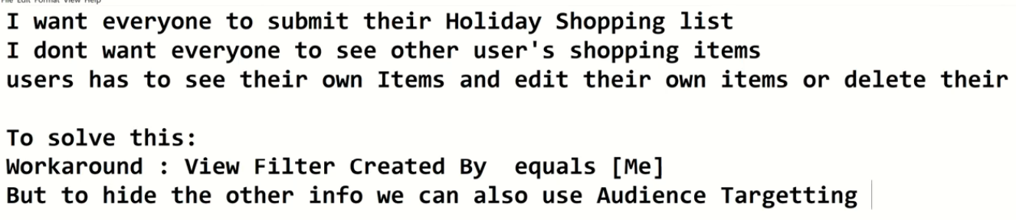

**Case 1: By using view_** Hidding

If we get the link we can access

This is the facke way

EX: Take Holiday shopping

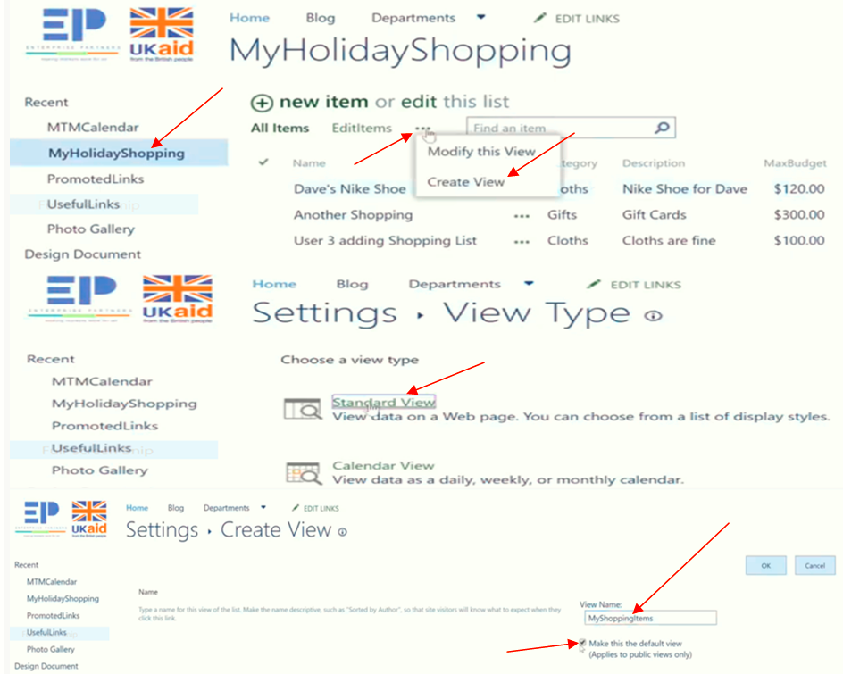

Order by: Name

Filter: Created by=> is equal to =>[Me]

Then we get

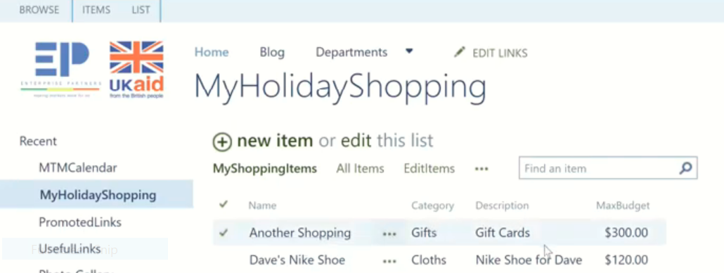

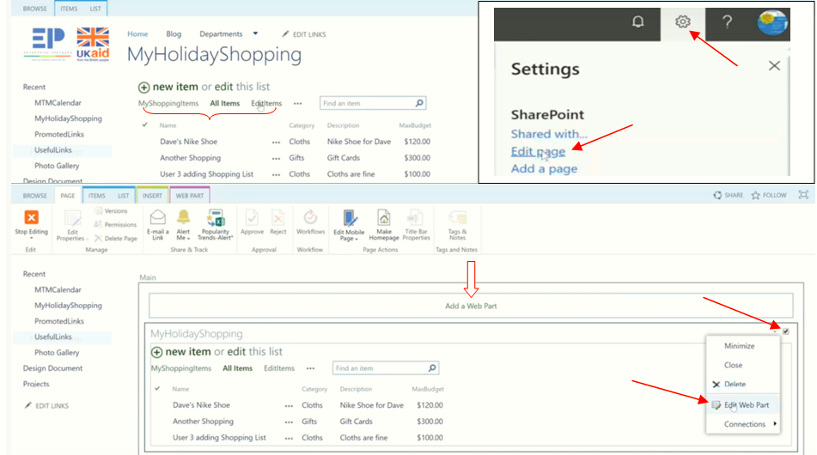

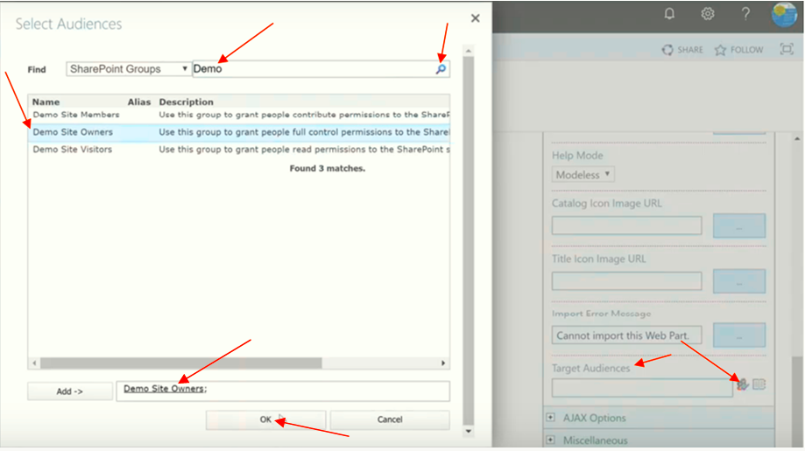

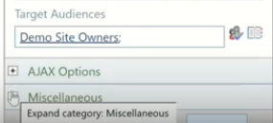

Look the following

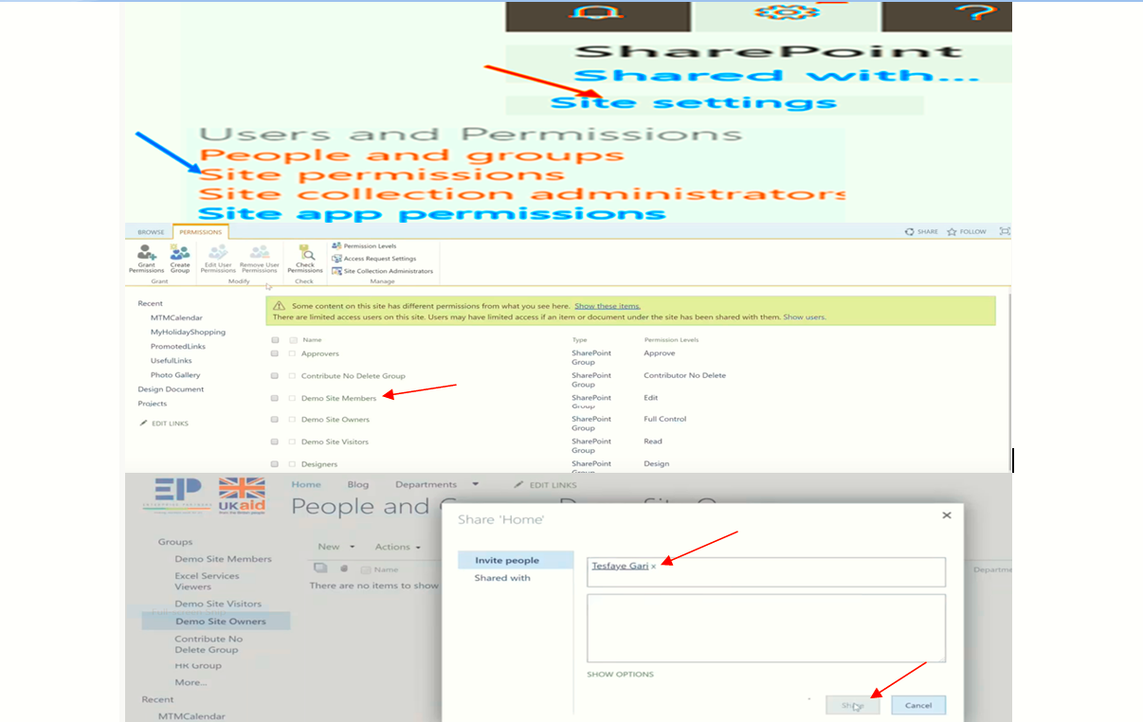

Admin: access all items

EX:

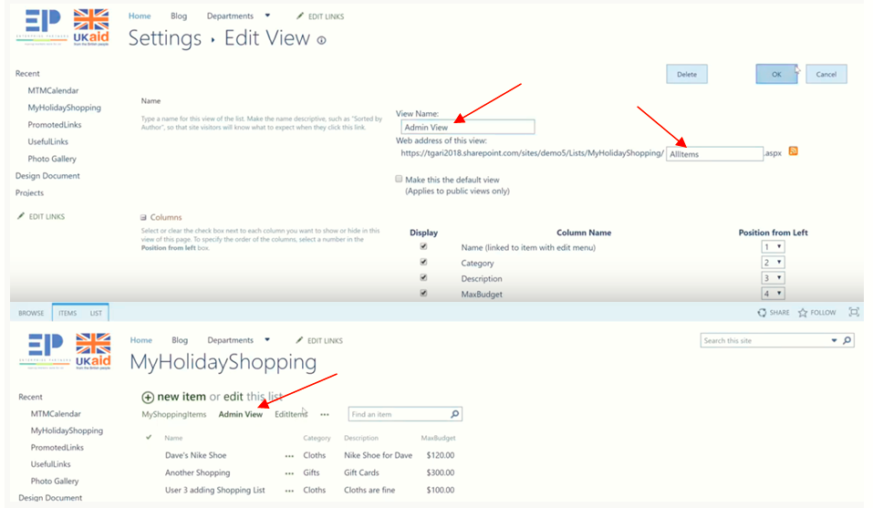

**Case 2: Permission**_Lucking

Even If we get the link we cann’t access

This is the right way

**To hide another shopping from user2/brake the permission**

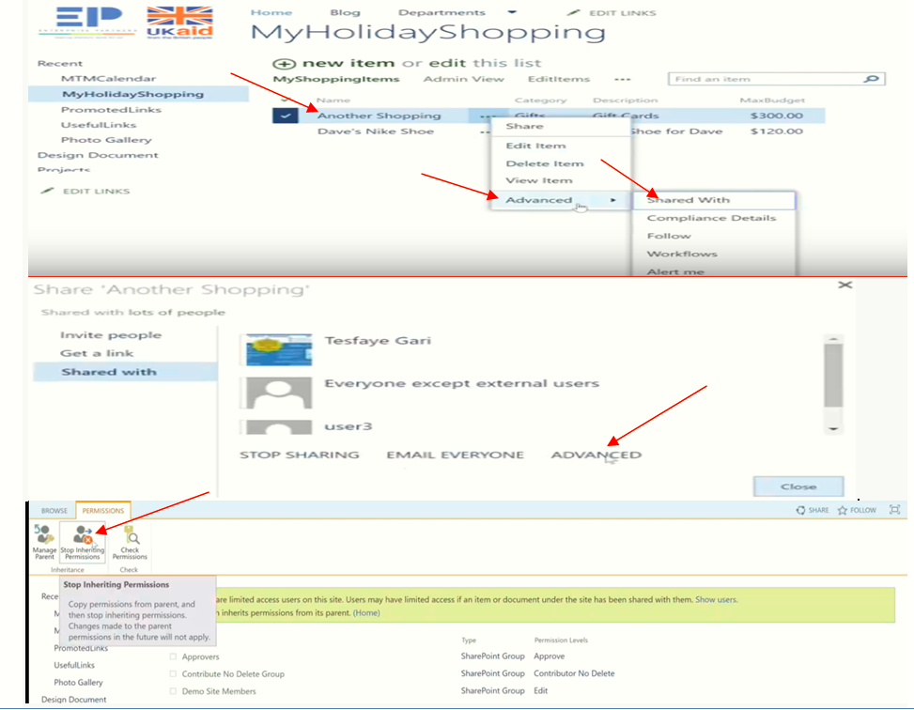

**List => list setting =>Advanced setting**

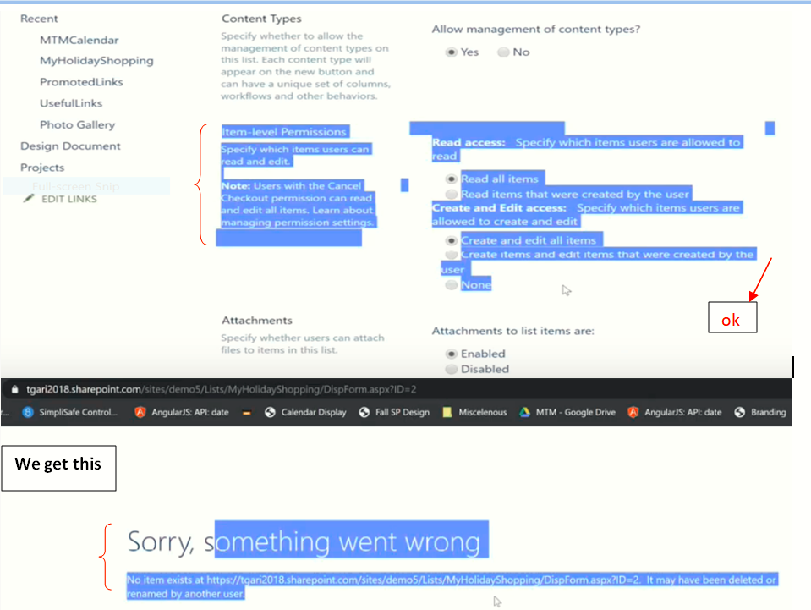

We give Editting permission/Add to User2

**List => list setting =>Advanced setting => Permission for this List =>**

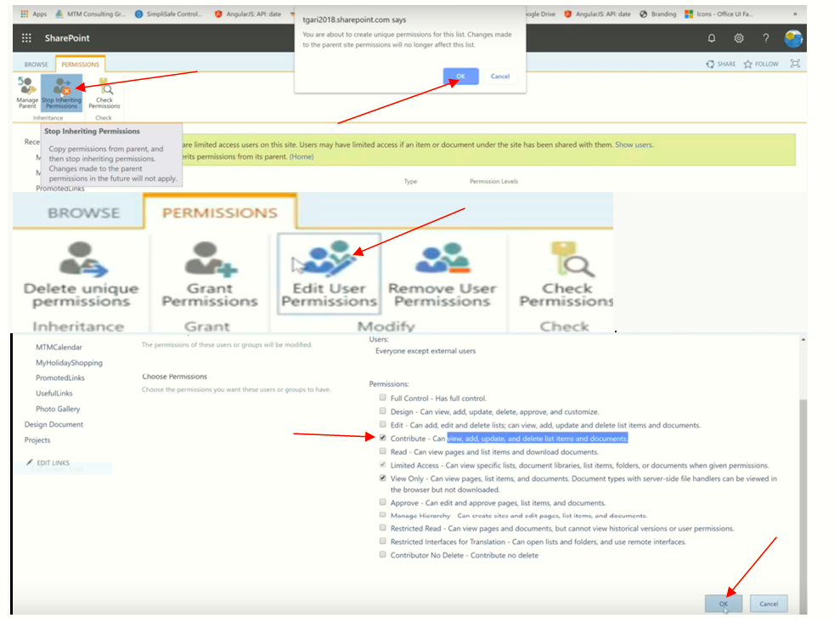

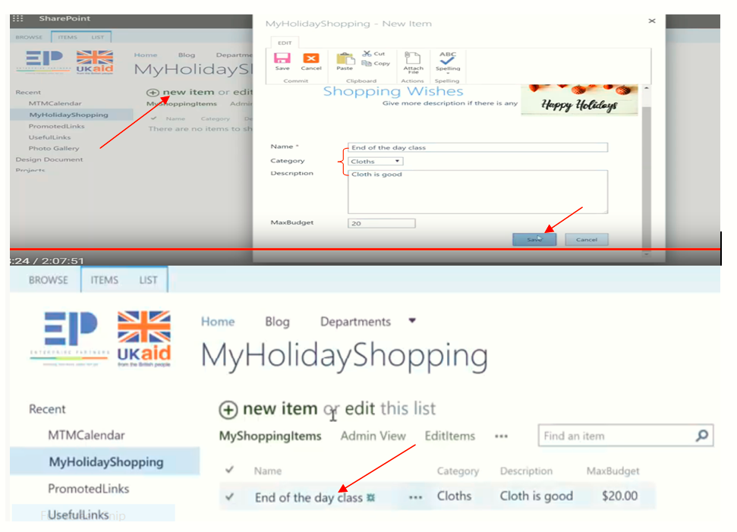

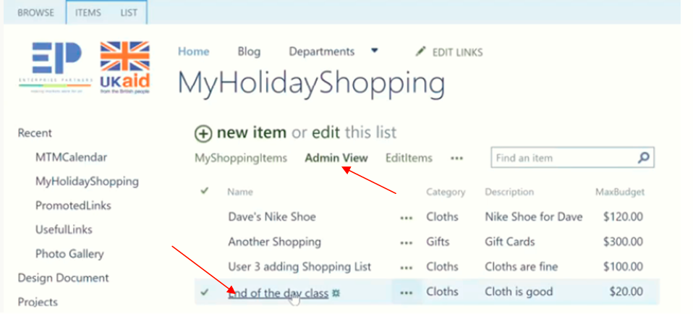

NB: To Share External user Anonymous user need

End of Class11